When on a contact Contact Summary View, Select add event, then pick “Contact Task”.
Contact Tasks can be assigned to the agent, assistant, closing coordinator, reservations, etc., whoever needs to complete the task.

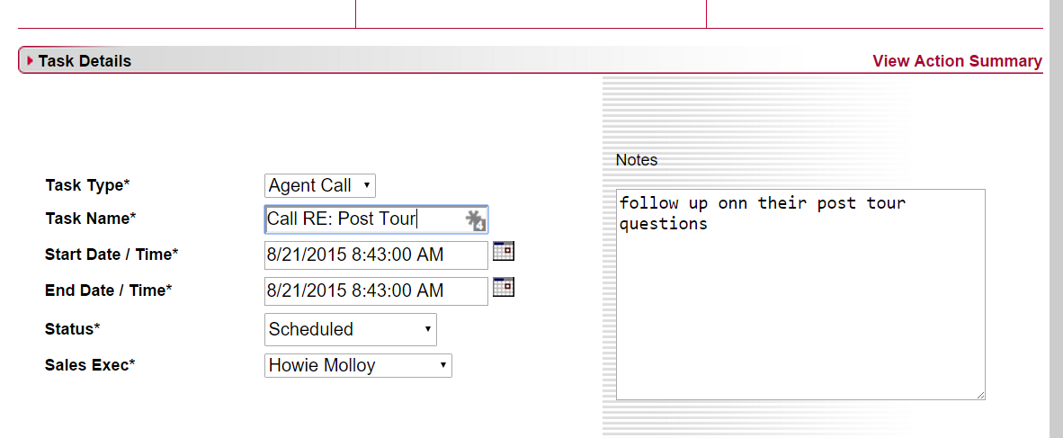

You can pull your assigned task list from the Actions Tab.
Change Action Type to “Tasks”
Status=Scheduled
Click Search
